Download Neo4j Desktop (might get warning from download, choose to keep)

Setting up local instance

- Click on “Local Instances” > “Create Instance”, enter instance name and set a password
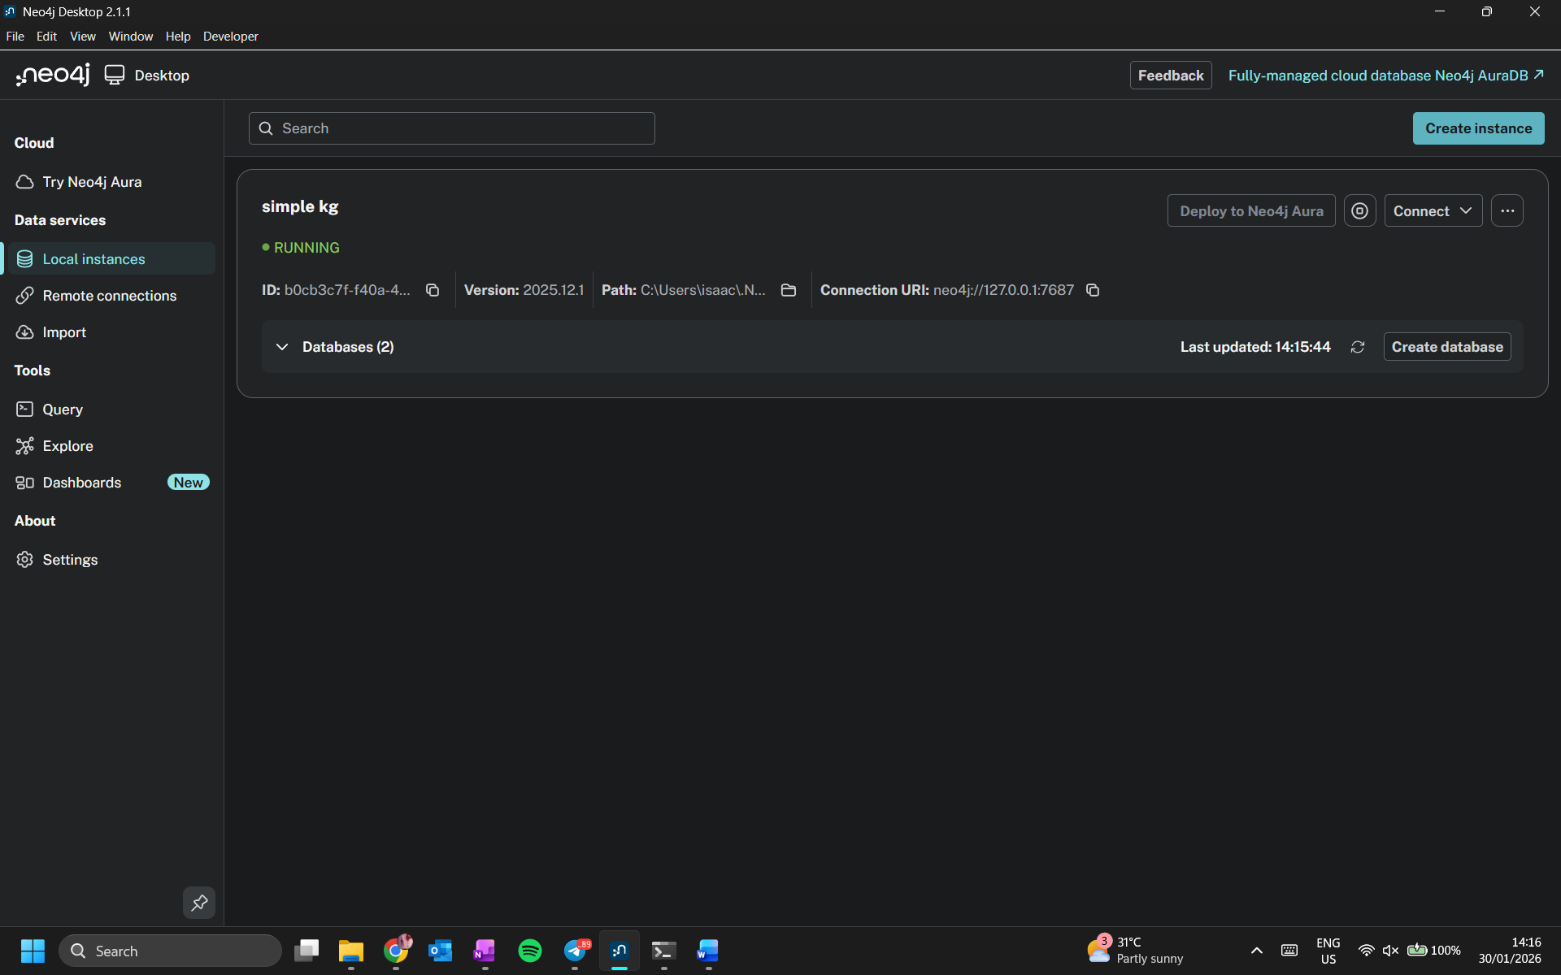
- Once instance has been initialized, click on “…” > “plugins” and install “APOC”, “Graph Data Science” or other plugins if needed. Restart instance if required.
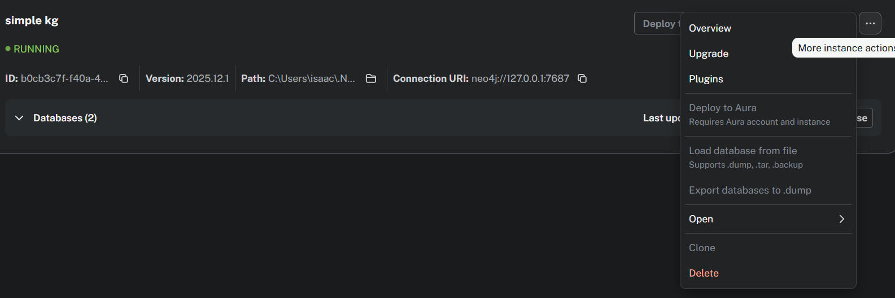
- Click on “…” > “Open” > “Instance Folder” > “conf”, create an “apoc.config” file, open with a text editor and paste this in
# Allow APOC to access the local file system for CSV/JSON loading
apoc.import.file.enabled=true
apoc.import.file.use_neo4j_config=true

  - To import data locally via file explorer, click on “…” > “Open” > “Instance Folder” > “import” and copy data files inside
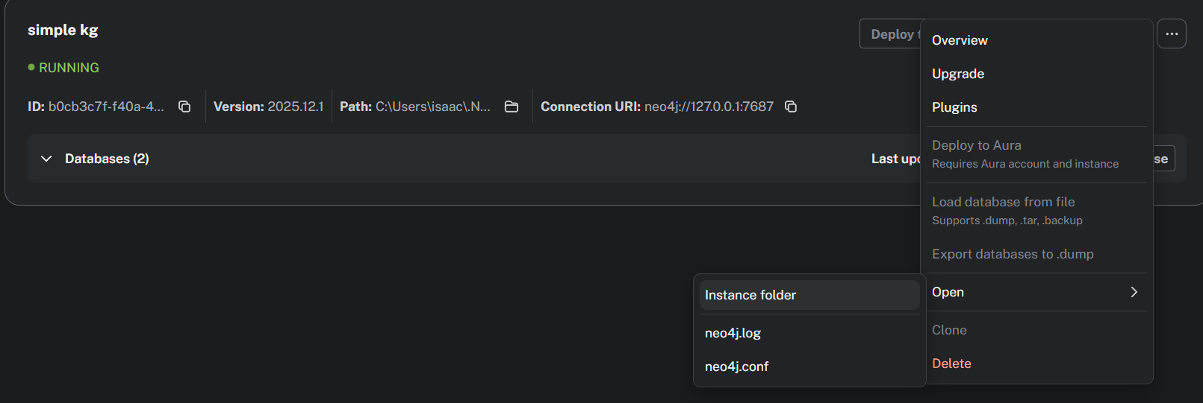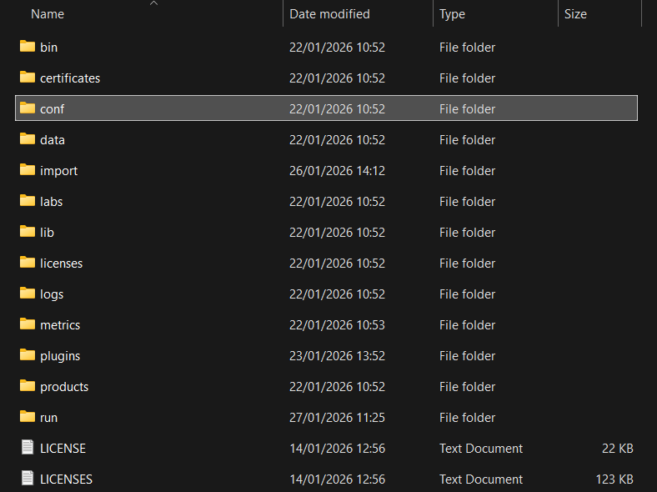
- Click on “Start Instance” and wait for the status to turn green and show “Running” (instance restart might be required when new files are uploaded to the database or new plugins are installed)
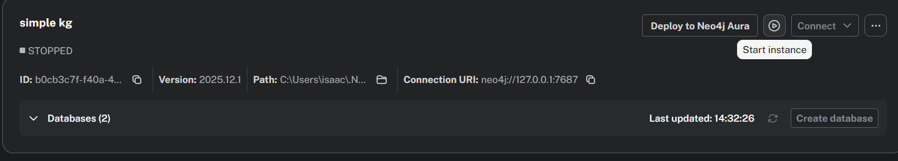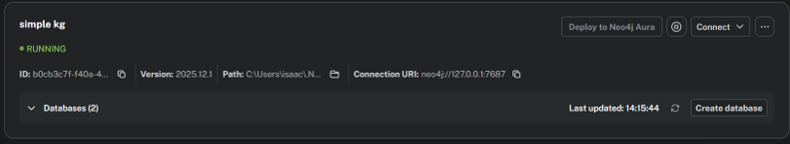

Using Query Tool

- Connect to running instance, if prompted to login again, login with password used when creating instance. (If login error either login again or wait awhile and connect again, usually works after awhile and a few tries)
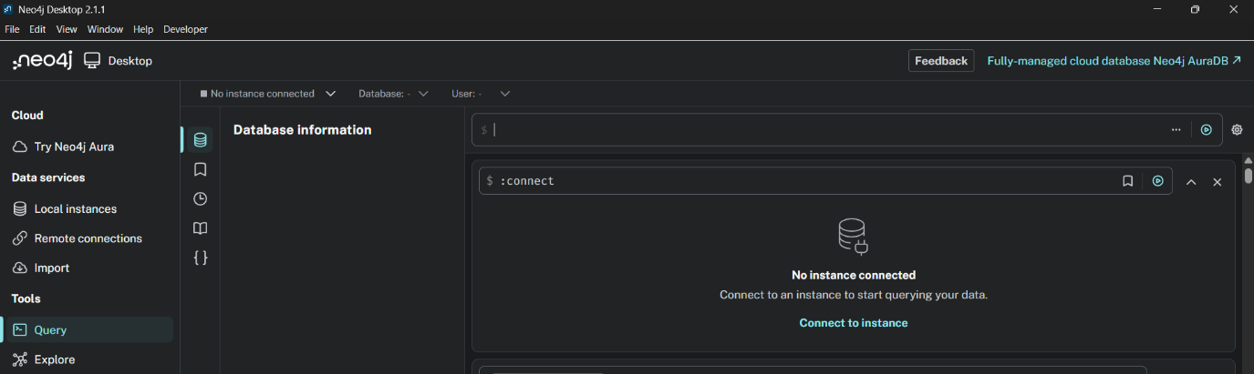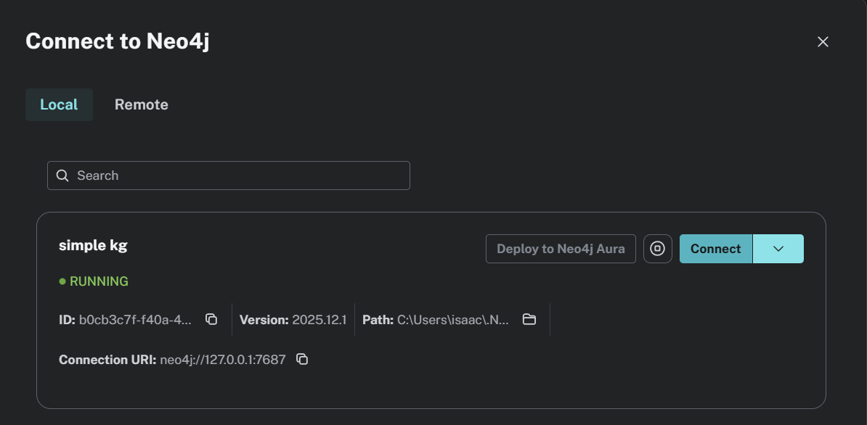
- When loading graph, load nodes first then edges
- Cypher queries can be saved/imported/exported from “Saved Cypher” tab
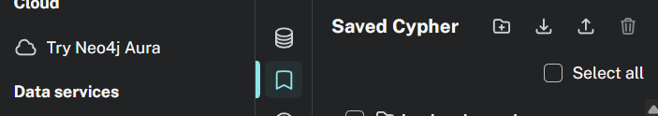

Using Explore Tool

Explore Tool shortcuts

Navigation & Zoom Shortcuts
Action | Windows / Linux
Expand Neighbors | Ctrl + E
Expand (Double-click) | Double-click Node
Select All | Ctrl + A
Invert Selection | Ctrl + Alt + A
Select Related | Ctrl + Shift + R
Hiding Nodes (Dismiss) | Ctrl + H
Hiding Others | Ctrl + Shift + H

Graph Interaction (Expand & Selection)
Action | Windows / Linux
Expand Neighbors | Ctrl + E
Expand (Double-click) | Double-click Node
Select All | Ctrl + A
Invert Selection | Ctrl + Alt + A
Select Related | Ctrl + Shift + R
Hiding Nodes (Dismiss) | Ctrl + H
Hiding Others | Ctrl + Shift + H
Clear Scene | Ctrl + Backspace
Dismiss Single Nodes | Ctrl + Shift + S

